EchoSphere Assignment 3 Testing Evidence
Testing and build verification completed on 14 October 2026 using disposable assignment data. The following screenshots record the observed results.

Integration Testing
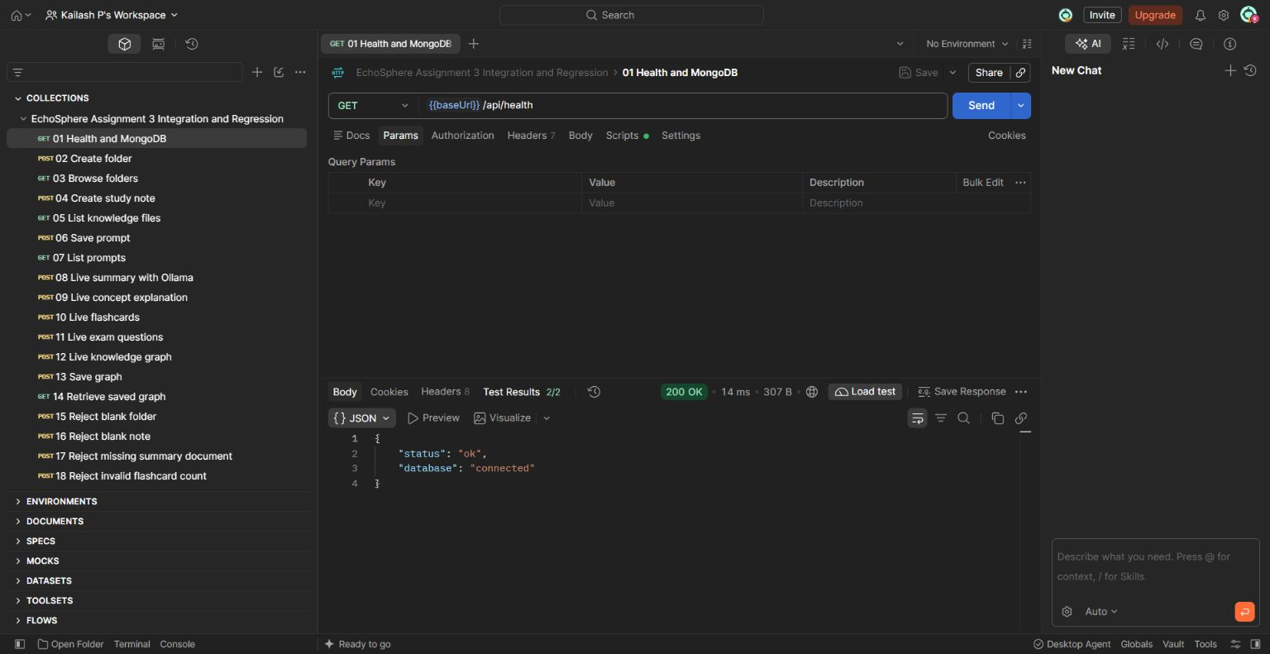
Postman returns HTTP 200 and passes both health assertions, confirming that Express is connected to MongoDB.

Integration Testing with Live AI
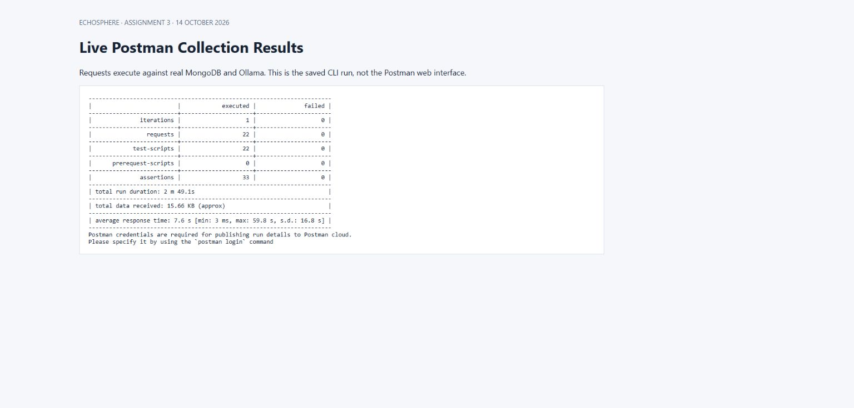
The saved Postman CLI execution passes all 33 assertions across 22 requests against real MongoDB and Ollama.

Regression Testing
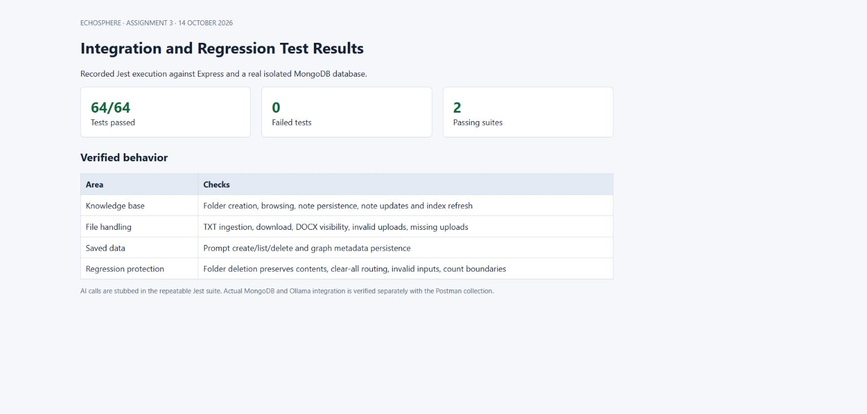
Jest passes 64 tests covering persistence, file handling, input validation and previously broken workflows.
The repeatable Jest integration suite uses real MongoDB with AI calls stubbed; the separate live Postman run exercises the actual AI services.

Mutation Testing
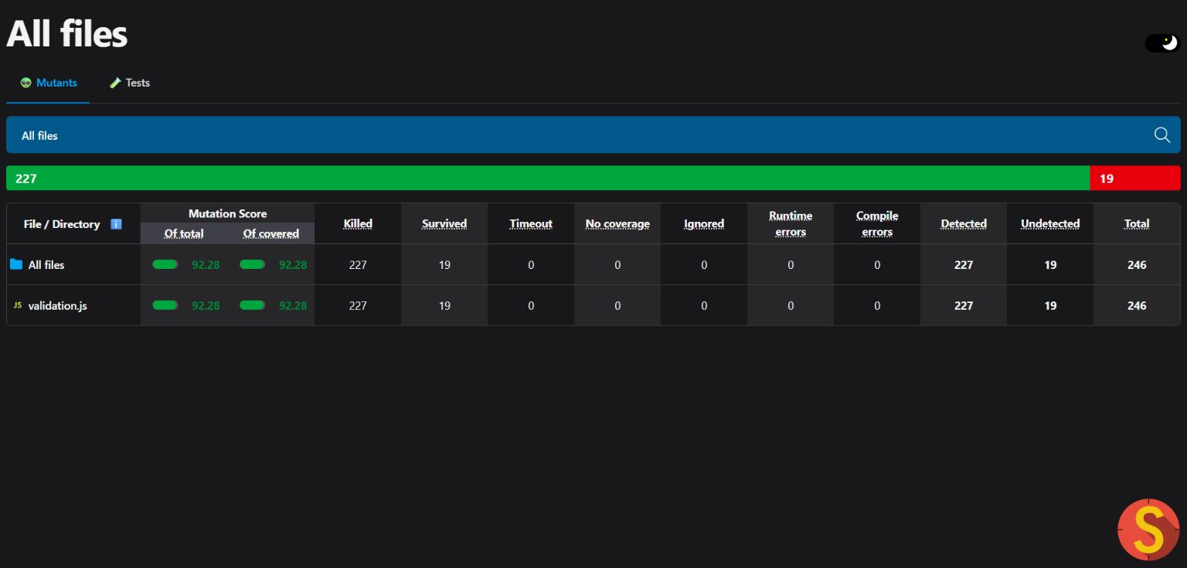
Stryker detects 227 of 246 mutations in backend validation with a 92.28 percent mutation score.
Scope is the API input-validation module. Nineteen mutations survive; this is not a project-wide mutation score.

Version Management and System Building
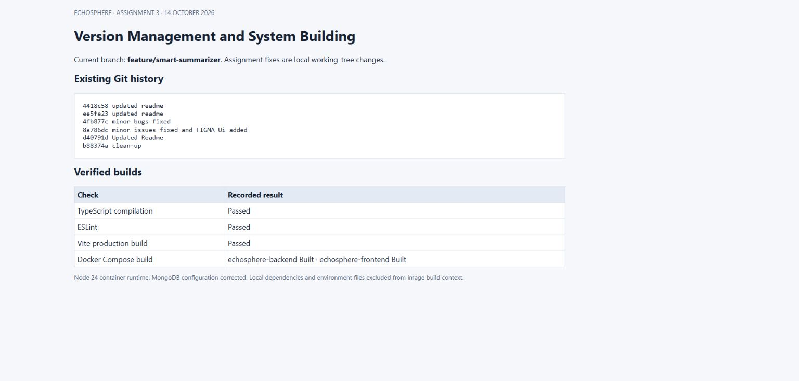
Git history is recorded and TypeScript, ESLint, Vite and both Docker image builds pass.
The assignment changes remain local on the existing feature branch and have not been committed or pushed.

Developed Functionality Knowledge Base
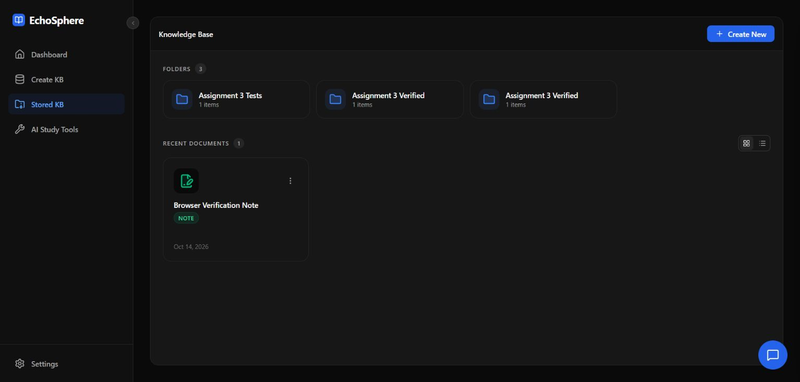
A note created through the browser appears in the stored knowledge base after the API saves it to MongoDB.

Developed Functionality Flashcards
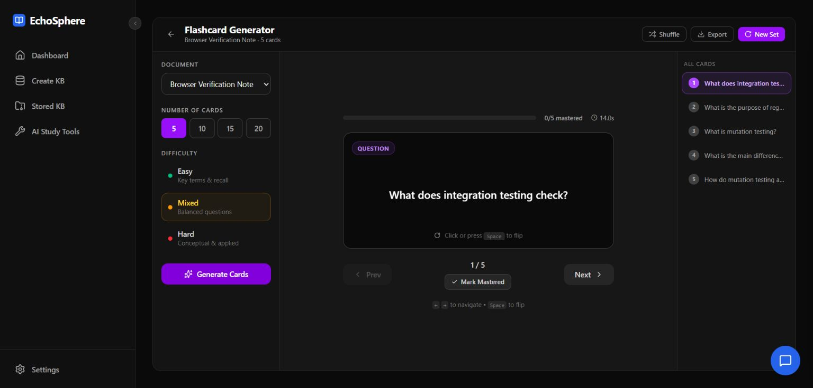
Ollama generates study flashcards from the selected note and the browser displays the resulting questions.

Tools and Technologies Used
Application React 19, TypeScript, Vite, Tailwind CSS, Express 5 and Node.js 24.
Data and AI MongoDB with Mongoose, LanceDB vector search, Ollama llama3.2:1b and nomic-embed-text.
Testing Postman CLI and Postman web interface with Desktop Agent, Jest, Supertest and Stryker Mutator.
Build and Evidence Git, Docker Compose, browser screenshots and an editable Word evidence document.

Test Coverage
Integration: health, folders, notes, upload and download, saved prompts, graph persistence and live AI tools.
Regression: TXT ingestion, DOCX file visibility, note reindexing, folder-content preservation, clear-all routing and malformed inputs.
Mutation: required text fields, identifier formats, conversation history, graph structure and count boundaries.
Browser: create a note, verify stored content, generate flashcards and display the results.

Reproducing the Tests
Run npm test in backend with the isolated MongoDB test container available on port 27018. Run npm run test:mutation for the focused mutation analysis. Import EchoSphere.postman_collection.json and run it against the assignment backend on port 5000 with Ollama running.

